Lab: DOM XSS in innerHTML sink using source location.search
Prepared by: Nihar Mane

INDEX
Report Metadata……………………………………………………………………………………………..2
Executive Summary…………………………………………………………………………………………2
Scope…………………………………………………………………………………………………………2
Methodology………………………………………………………………………………………………….2
Step-by-Step Execution……………………………………………………………………………………..2
Impact Assessment………………………………………………………………………………………….3
Remediation………………………………………………………………………………………………….3
Conclusion……………………………………………………………………………………………………3
References……………………………………………………………………………………………………3

Report Metadata

Lab: DOM XSS in innerHTML sink using source location.search — PortSwigger Web Security Academy (Apprentice). Target: blog search feature (/?search=). Tools: browser address bar / DevTools. Tester: Nihar Mane. Date: August 27, 2026. Status: Solved — alert(1) executed, lab banner reads “Solved” (Figure 1).

Executive Summary

This lab demonstrates a DOM-based XSS vulnerability where the blog’s search page writes the search term into the page’s innerHTML without encoding it. Submitting <img src=1 onerror=alert(1)> creates an image with an invalid source, and the resulting error triggers the onerror handler, executing arbitrary JavaScript.

Scope

In scope: the search parameter on the blog search page of the assigned PortSwigger lab instance. Out of scope: all other endpoints and any production system.

Methodology

Submit a payload in the search box that forces an invalid resource load and attaches a JavaScript event handler, then observe whether the handler executes.

Step-by-step Execution

Step 1: Enter the following into the search box: <img src=1 oneerror=alert(1)>
An error is thrown because the src attribute's value is invalid. As a result, the onerror event handler calls alert (). Consequently, whenever the user's browser tries to load the site containing your malicious post, the payload executes.
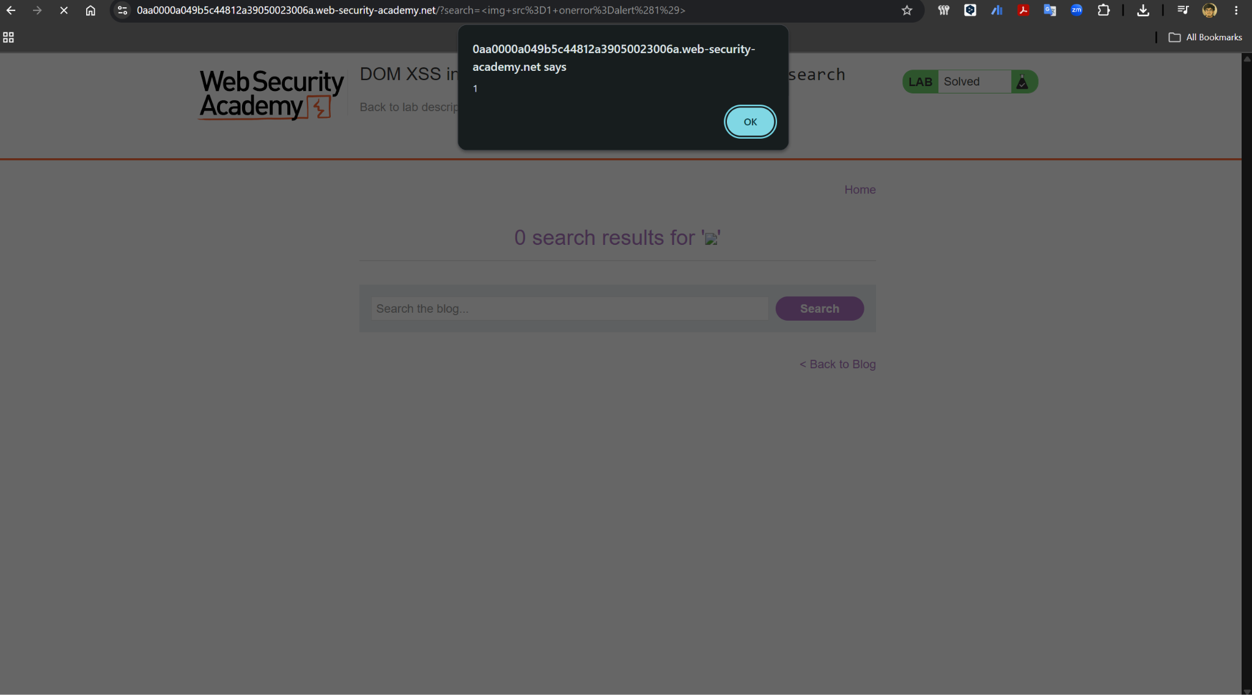

Impact Assessment

• Client-side, purely DOM-based: the payload never reaches the server, so it can evade server-side filters and logging.
• Full script execution: an attacker can hijack the victim’s session or perform actions as them once the handler runs.
• Easy delivery: the attack only requires getting a victim to click a crafted search URL.

Remediation

• Avoid assigning unsanitized data to innerHTML; use safe DOM APIs like textContent instead.
• If HTML must be inserted dynamically, HTML-encode any data taken from the URL or other attacker-controllable sources first.
• Apply a Content Security Policy to limit the impact of any script that does execute

Conclusion

This lab confirmed that an unsanitized innerHTML assignment is enough to achieve full script execution from a purely client-side data flow, with the server never seeing the payload. As with the earlier XSS labs, the fix is to never let attacker-controlled data reach an unsafe DOM sink unescaped.

References
- LAB https://portswigger.net/web-security/cross-site-scripting/dom-based/lab-innerhtml-sink

